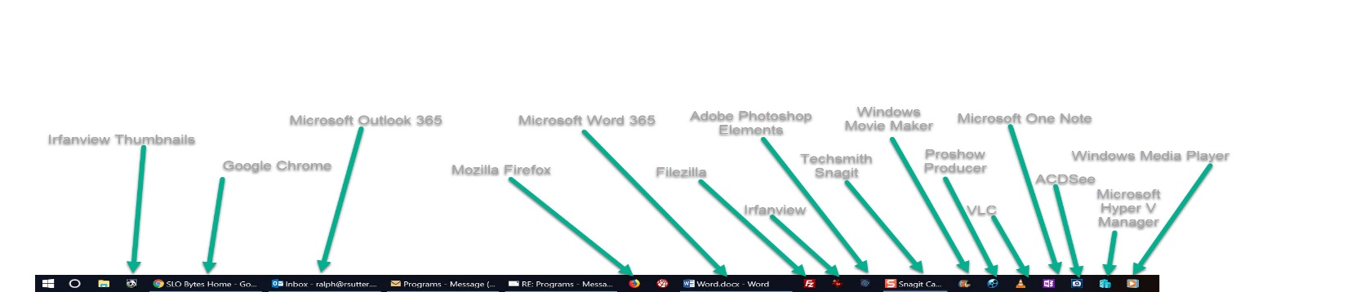
Sutter Frequently Used Programs
Sutter Taskbar

Google Chrome Browser; https://support.google.com/chrome/answer/95346?co=GENIE.Platform%3DDesktop&hl=en
Duck Duck Go Search Engine Extension for Chrome
https://support.google.com/chrome/answer/95346?co=GENIE.Platform%3DDesktop&hl=en
Microsoft Office 365; https://products.office.com/en-us/products ($99)
Mozilla Firefox Browser; https://www.mozilla.org/en-US/firefox/new/
Filezilla File Transfer Program; https://filezilla-project.org/
Irfanview Graphical Viewer; https://www.irfanview.com/
Adobe Photoshop Elements 2019 and Adobe Premiere Elements 2019;
https://www.adobe.com/products/premiere-elements.html ($149.99)
Techsmith Snagit 2019; https://www.techsmith.com/screen-capture.html ($49.95)
Adobe Homesite Web Editor; (no longer available for purchase)
Microsoft Movie Maker; (freeware; no longer available)
Photodex Proshow Producer 9.0 Slideshow Creation Software; http://www.photodex.com/proshow/producer ($249.95)
VLC Media Player; https://www.videolan.org/
Microsoft One Note; https://www.onenote.com/Download
ACDSee Ultimate 9; https://www.acdsee.com/en/index

